Vendor Performance Analysis Report

### Business Problem:

Effective inventory and sales management are critical for optimizing profitability in a business. Proper analysis is required in order to reduce losses and identify the inefficient links. The goal of this project is to:

1. Identify underperforming brands that need promotional or pricing adjustments.
2. Determine the top vendors contributing to sales.
3. Determine top brands contributing to sales.
4. Identify the maximum contributing vendors.
5. Getting insights into inventory management through key indicators.

### Data Insights:

In this project, a Python script was developed to automate the data ingestion and processing pipeline using pandas, os, and SQLAlchemy. First, all CSV files from the specified folder were read and loaded into an SQLite database (inventory.db) as individual tables. Using SQL queries, a new table vendor_sales_summary was generated by joining purchase, sales, price, and freight-related data. This summary table captures important metrics such as total sales, purchase costs, freight charges, and quantities. The data was then cleaned — missing values were handled, text fields were trimmed, and data types were corrected. Additional performance indicators like gross profit, profit margin, stock turnover, and sales-to-purchase ratio were calculated and added to the dataset. The final cleaned summary was saved back to the database for use in further analysis and visualization. The following is the analysis of the vendor_sales_summary table.

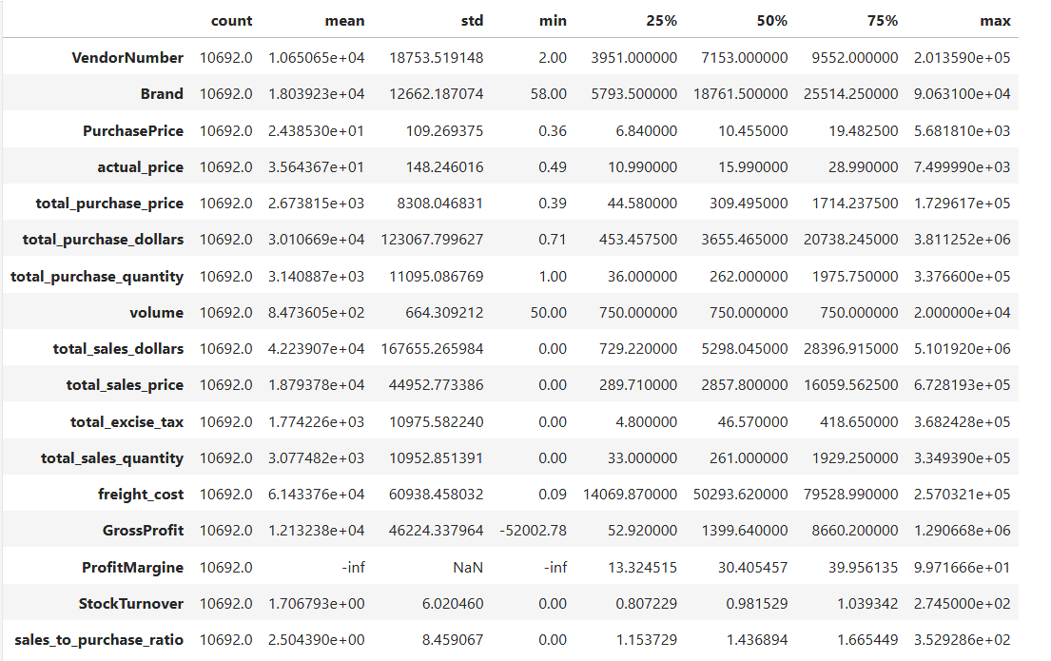

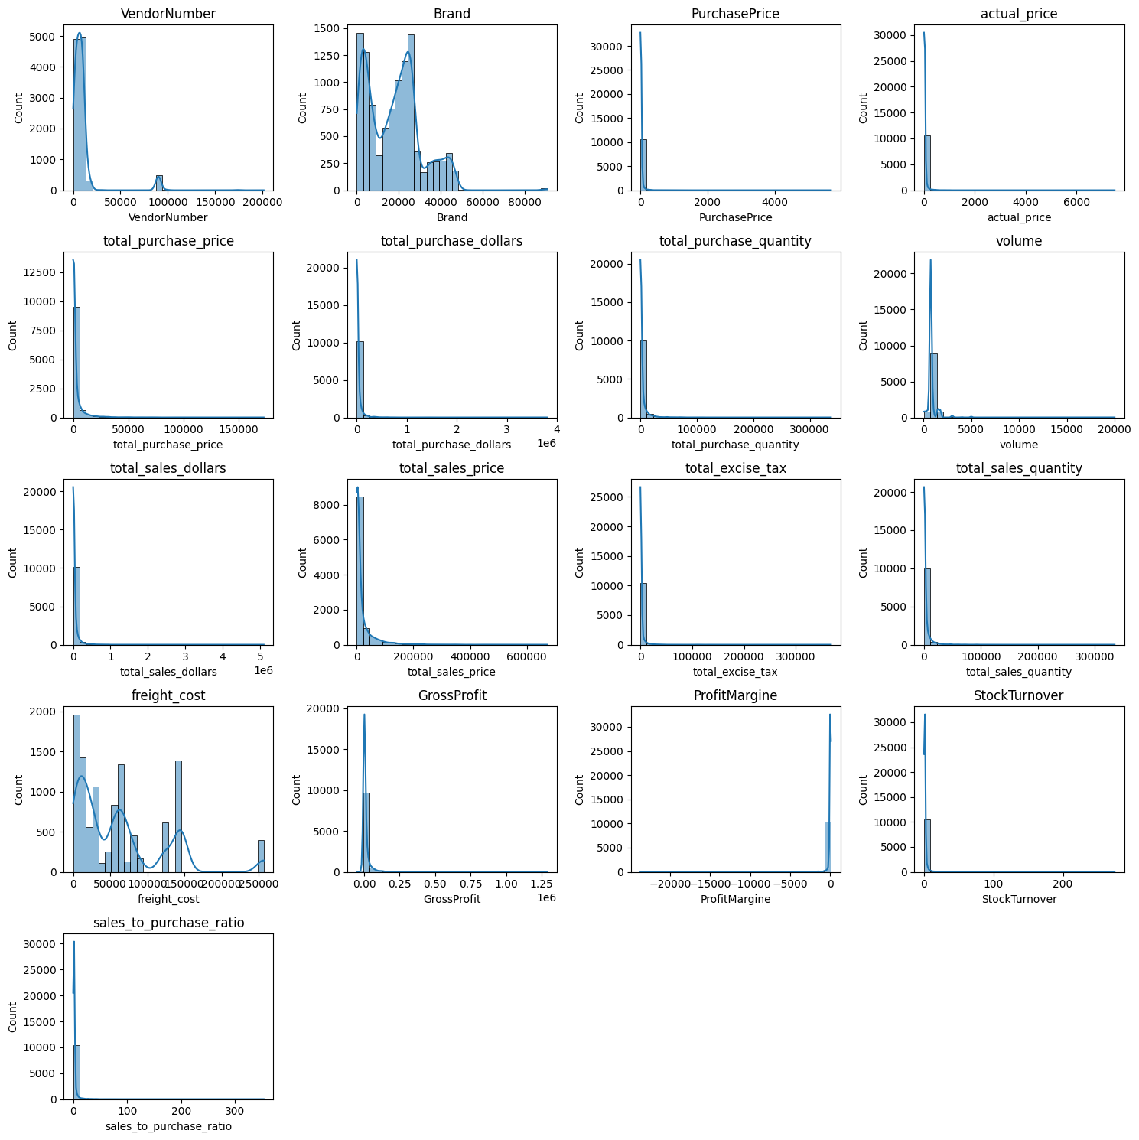

**Negative and Zero values:**

**Gross Profit:** Indicate potential loss may be because of selling the product at a cost less than the purchase price.

**Profit Margin:** Has a minimum of negative infinity, indicating where revenue is 0

**Total Sales Quantity and Sales Dollars:**  Some products show zero sales, indicating they were bought but never sold.

### Data Filtering:

where gross profit>0

and profit margin>0

and total_sales_quantity>0

### Correlation Insights:

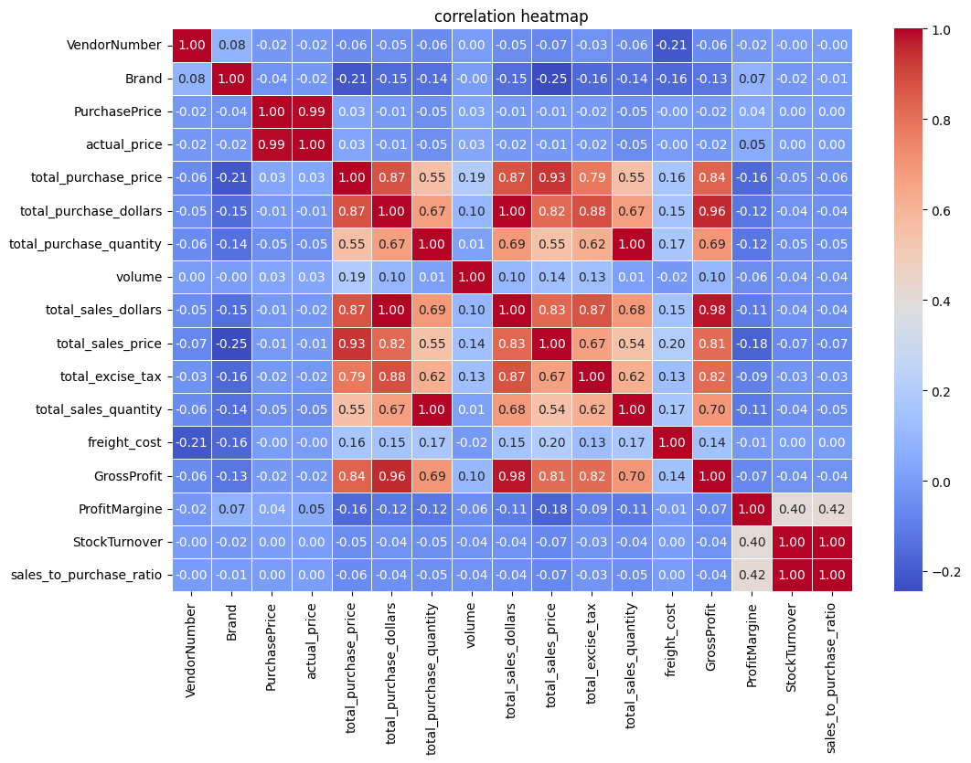

### Brands for promotional price adjustments:

Brands with total sales less than the threshold and profit margin more than the threshold value are potential targets for pricing adjustments.

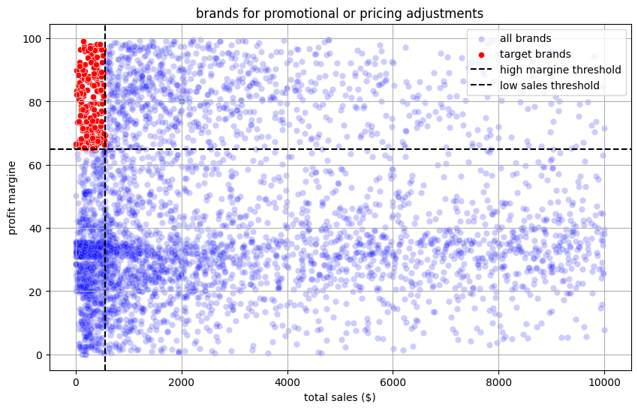

### Other insights:

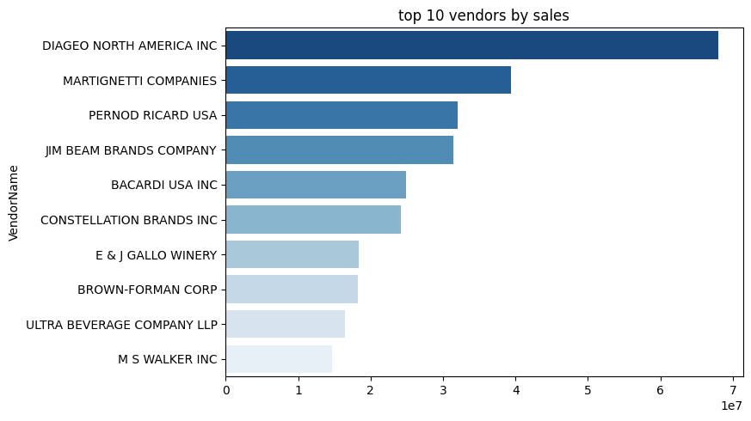

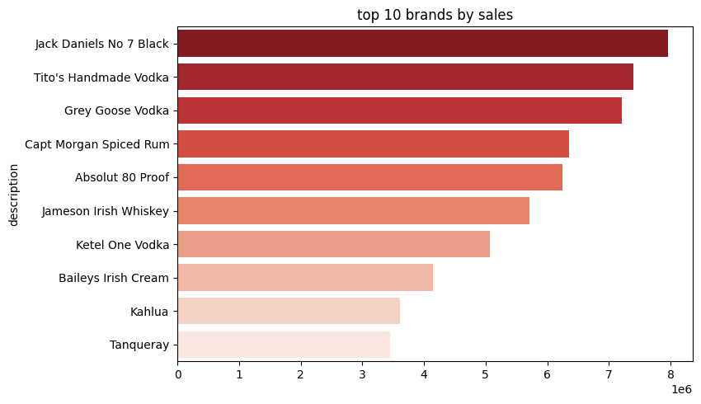

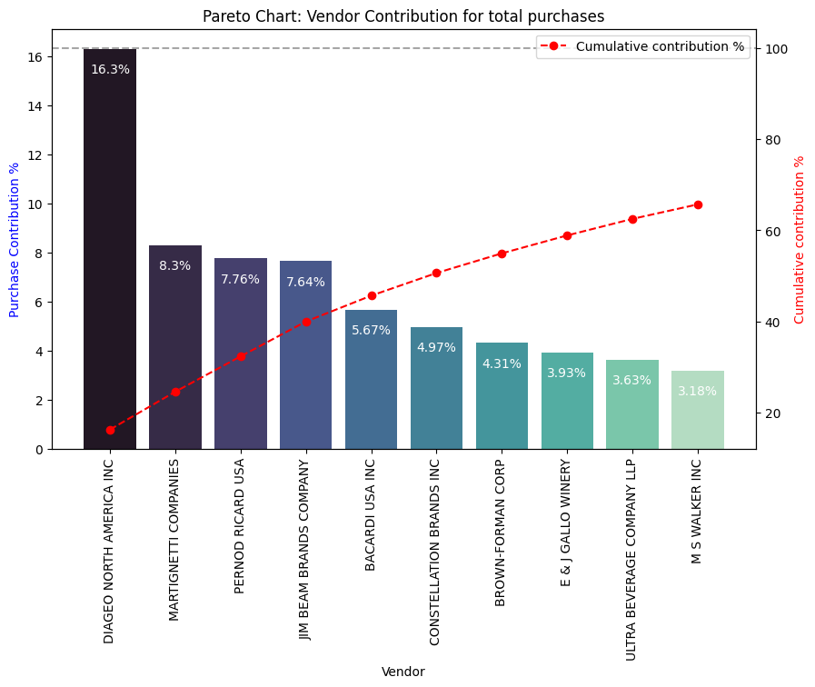

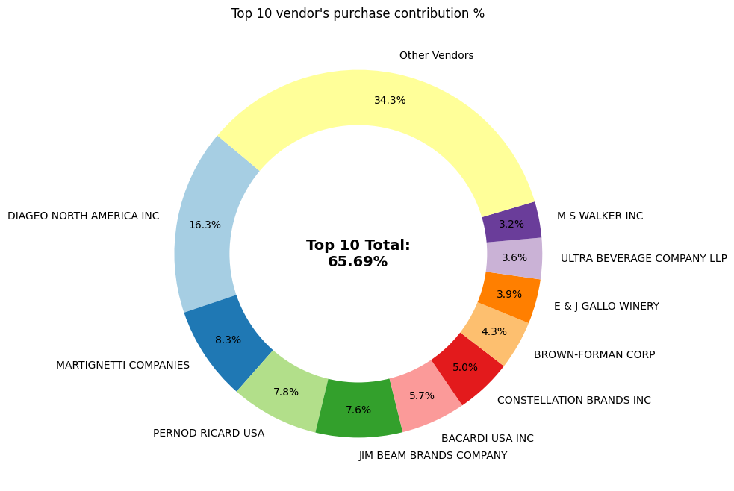

vendors with low inventory turnover, indicating excess stock and slow-moving products:

| **Vendor Name** | **Stock Turnover** |
| --- | --- |
| **ALISA CARR BEVERAGES** | 0.615385 |
| **HIGHLAND WINE MERCHANTS LLC** | 0.708333 |
| **PARK STREET IMPORTS LLC** | 0.751306 |
| **Circa Wines** | 0.755676 |
| **Dunn Wine Brokers** | 0.766022 |
| **CENTEUR IMPORTS LLC** | 0.773953 |
| **SMOKY QUARTZ DISTILLERY LLC** | 0.783835 |
| **TAMWORTH DISTILLING** | 0.797078 |
| **THE IMPORTED GRAPE LLC** | 0.807569 |
| **WALPOLE MTN VIEW WINERY** | 0.820548 |

how much capital is locked in unsold inventory per vendor, and who contributes most (top 10)

| **VendorName** | **Unsold_inventory_value** |
| --- | --- |
| DIAGEO NORTH AMERICA INC | 722209.05 |
| JIM BEAM BRANDS COMPANY | 554665.63 |
| PERNOD RICARD USA | 470625.61 |
| WILLIAM GRANT & SONS INC | 401960.83 |
| E & J GALLO WINERY | 228282.61 |
| SAZERAC CO INC | 198436.41 |
| BROWN-FORMAN CORP | 177733.74 |
| CONSTELLATION BRANDS INC | 133617.62 |
| MOET HENNESSY USA INC | 126477.70 |
| REMY COINTREAU USA INC | 118598.15 |

### Dashboard:

The following dashboard gives deeper insights into various indicators and features of inventory management.

